2021 Level 3 State Championships
The Miller Center for Recreation & Wellness
120 Hardwood Drive
Lewisburg, PA 17837
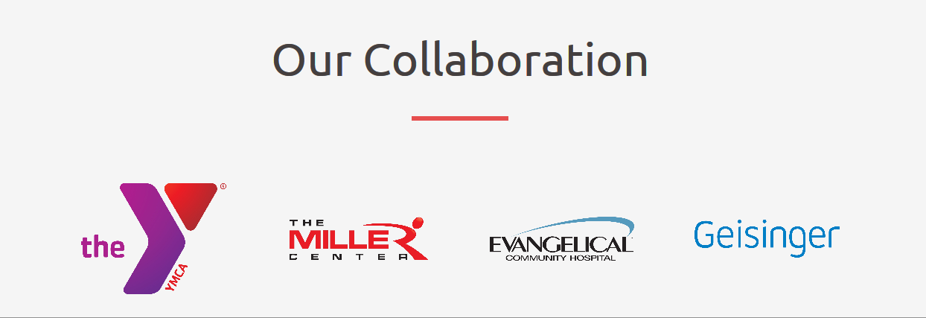

Hosted By Dynamats Gymnastics Center
May 14 – 16th, 2021

Dynamats Gymnastic Center welcomes and congratulates your gymnasts on their qualification to the
2021 Level 3 State Championships. We wish you safe travels and look forward to seeing you in a few short weeks!

Host Club: Dynamats Gymnastic Center
(570)935-0575
https://www.dynamats.com; go to the state/regional meet tab

Entries/ Registration: Through Meet Maker
Questions: Heather Kikel – Competition Coordinator: heather@centreelitegym.com
Monica Fessler - Meet Director: mrf5319@gmail.com

Registration
Fee: $85 per gymnast

Registration
Deadline: Monday, April 26th, 2021 by Midnight (Including petitions)- Entries received after will incur a $25 late fee.

Competition
Site: The Miller Center for Recreation & Wellness
120 Hardwood Drive
Lewisburg, PA 17837

Directions: See “Directions & Parking” Sheet at the end of this packet.

Hotel
Information: See “Hotel Information” in packet.

Admission:
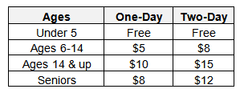
Dynamats ONLY accepts CASH for admissions
Coaches & All competitors may attend other sessions free of charge with athlete pass.

Food
On site: Visit their café menu at: https://millercenterlewisburg.com/cafe/
They accept Visa, MasterCard, Discover, and American Express
Café WILL BE open during all hours of the meet!

Awards: Individual Event and All-Around awards will be presented to each age group at
the conclusion of each competition session per the Rules & Policies requirements. Placements will out a minimum of 25% for awards.

Results: Running scores will be available near the head table. Final results will be posted
on the state website after the competition. Scores will be posted at MeestScoreOnline.com and MyUSAGym.com

Equipment: AAI equipment supplied by Mancinos Mats to include:
Vault: AAI TAC/10 LZT Vault Boards
Bars: AAI ELITE Uneven Bars with Graphite E (soft) rails 12cm base mat
Beam: AAI ELITE RA Balance Beam 12cm base mat
Floor: American ELITE Artistic Floor Exercise System
8” skill cushions, 4” supplemental throw mats and sting mats available at every event

Meet Format: Modified Capital Cup

Session
Schedule: Will be posted at https://www.dynamats.com

Coaches
Meeting: There will be a coaches meeting at the beginning of each session.

Coaches
Sign-In: Coaches should be pre-registered in the Meet Reservation System. Coaches will
be asked to show their USA Gymnastics Professional Member card at sign-in.
Please be sure all requirements are current: MEMBERSHIP, SAFETY CERTIFICATION, BACKGROUND CHECK and U100.
*Only professional members who are coaching and athletes competing in
the current session are allowed on the competition floor.

Coaches
Food: Food vouchers will be handed out to coaches to use at the Miller Center’s café

Safety: For the safety and consideration of ALL athletes, coaches and spectators, no
injured or sick athletes should participate in the competition.

Hotels:

Quality Inn New Columbia  330 Commerce Park  New Columbia, PA. 17856  570-568-8000 | Country Inn & Suites by Radisson  134 Walter Dr.  Lewisburg, PA. 17837 | Best Western Plus Country Cupboard Inn  7701 West Branch Highway  Lewisburg, PA. 17837
Holiday Inn Express Lewisburg  160 Commerce Park Drive  New Columbia, PA. 17856 | Quality Inn Selinsgrove  613 North Susquehanna Trail  Selinsgrove, PA. 17870 | Holiday Inn Express Selinsgrove  651 North Susquehanna Trail  Shamokin Dam, PA. 17870
Comfort Suites Lewisburg  4775 West Branch Highway  Lewisburg, PA. 17837 | Hampton Inn Selinsgrove/Shamokin Dam  3 Stetler Ave.  Shamokin Dam, PA. 17876 | All Suites Inn  4663 West Branch Highway  Lewisburg, PA. 17837

Places to Eat:
Country Cupboard  101 Hafer Rd, Lewisburg | Elizabeth's An American Bistro  412 Market St, Lewisburg | Siam Restaurant & Bar  518 Market St, Lewisburg
Reba & Pancho's Restaurant  2006 W Market St, Lewisburg | LA Primavera Italiano  Ristorante & Pizzeria  2593 Old Turnpike Road. | Ard's Farm  4803 Old Turnpike Road
Town Tavern  600 Market St, Lewisburg | House of Pizza  524 Market St, Lewisburg | Bertoni's Pizza & Specialties  368 Railroad St, Montandon
Peking Garden  199 N Derr Dr, Lewisburg | Lewisburg Hotel  136 Market St, Lewisburg | Bull Run Tap House  605 Market St, Lewisburg

Colleges to visit:
Bucknell University  One Dent Drive  Lewisburg, PA17837 | Lycoming College  1 College Place  Williamsport, PA. 17701 | PA College of Technology  1 College Ave.  Williamsport, PA. 17701
Bloomsburg University  400 E. Second St.  Bloomsburg, PA 17815 | Susquehanna University  514 University Avenue  Selinsgrove, PA 17870 | Lock Haven University  401 N. Fairview St.  Lock Haven, PA 17745
Things to do:
Street of Shops | Rollermills Antique Center | Lewisburg Farmer’s Market
The Campus Theater | Fero Vineyard & Winery | Lewisburg Antique and Consignment Mall
Lewisburg Children’s Museum | Fantasy Escape Room | Hufnaugle Park
***Lewisburg’s downtown main street has several unique shops and boutiques available to browse!***

Directions + Parking:
The Lewisburg YMCA at The Miller Center is NOT on Apple Maps. Hardwood Drive is also NOT on Apple Maps.
We are, however, on Google Maps.
GPS location: 120 Hardwood Drive, Lewisburg, PA 17837
Latitude and Longitude: 40.960997, -76.896981
The Lewisburg YMCA at The Miller Center has over 240 parking spaces in our two parking lots located on the East and West sides of the building. Should those lots become full, you’ll find additional parking at a few neighboring parking lots, including:
- MC Financial Credit Union and Central Susquehanna LPN Career Center
1339 St Mary St, Lewisburg, PA (approximately .2 miles/3 minute walk to The Lewisburg YMCA at The Miller Center)
- Union County Government Center
155 N 15th St, Lewisburg, PA (approximately .25 miles/4 minute walk to The Lewisburg YMCA at The Miller Center)
We ask that you please do NOT use parking spaces at Giant or any other merchant within Penn House Commons as they are reserved for shoppers. Thank you for your consideration.

**MAP ON NEXT PAGE**
